Equations - Worksheet A answers
1 a x = 13 b x = 16 c x = 3 d x = 18
2 a x = 4 b x = 3 c x = 10 d x = 21
e x = 5 f x = 8
3 a x = 4 b x = 2 c x = 5 d x = 4

4 a u = 4 b t = 6
5 a 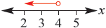
b 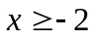 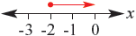
6 a b 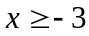
7 (1, 3)
8 a (13, −4) b (1, 2) c (2, 5)
9 Frank is 15 and Beth is 8
10 Highlighters cost $3 and pens cost $2

